Sean Mayers

Week 3 - Inheritance 2

11/8/20

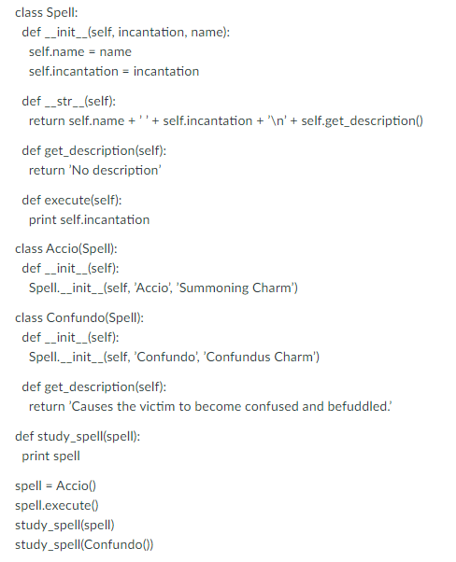

1. What are the parent and child classes here?

The parent class is Spell. Child classes are Accio and Confundo.

2. What are the base and sub-classes?

The base class is the same as parent class which is Spell. Sub-classes are the same as Child classes and are Accio and Confundo.

3. What is the output from this code? Try without running if you can

Accio  
SummoningCharmAccio

No description

4. When study_spell(Confundo()) executes...what get_description method gets called and why?

It doesn’t get called and produces an error confundo is not declared.

5. The statement print Accio() needs to print ‘This charm summons an object to the caster, potentially over a significant distance’)? Write down the code that we need to add and/or change.

Adding another method then call at end of program:

def distance(self):

print("This charm summons an object to the caster potentially over a significant distance")

now spell.distance()